Types of mobile applications:

* Native applications
* Mobile web applications
* Hybrid web applications

Native applications:

* Built for a single platform
* Fast compared to other types of apps
* More interavtie and intutive
* Manintanance is High

Mobile web applications:

* Deliver web pages on mobile browsers
* Do not require an installation

Hybrid applications:

* Blend of native and moble applications
* Do not offer a high front end performance

Moolya Mobile app testing Model:

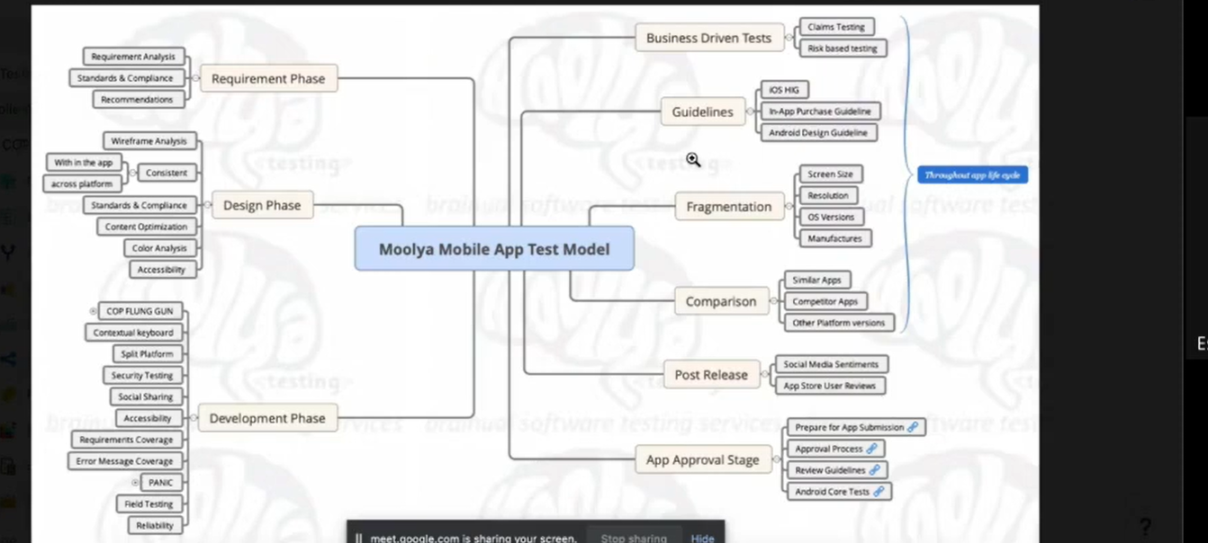

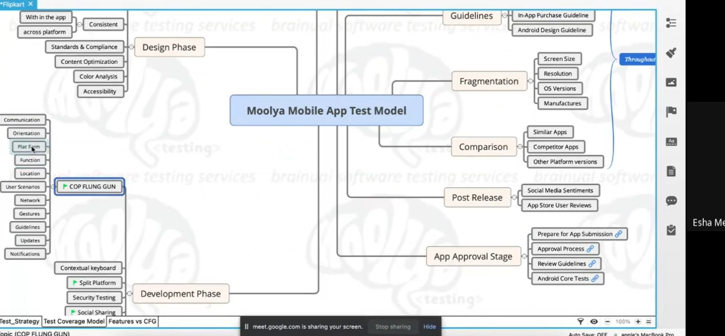

* Requirement Phase
* Desighn phase
* Development phase
* Buisiness driven tests
* Guidelines
* Fragmentation
* Comparison
* Post release
* APP Aprroval stage

**Requirement Analysis:**

* Requirement analysis
* Standards & compliance
* Recommendations

**Desighn phase:**

* Wireframe analysis
* Consistent (within the app, across platforms)
* Standards & compliance
* Content optimization
* Color analysis
* Accesbility

**Development phase:**

* COP FLUNG GUN
* Contexual keyboard
* Split platform
* Security testing
* Social platform
* Accesbility
* Requirments coverage
* Error messege coverage
* PANIC
* Field Testing
* Reliablity

**Busuiness driven tests:**

* Claims testing
* Risk based testing

**Guidelines:**

* IOS HIG
* In app purchase guidelines
* Android desighn guidelines

**Fragmentation**

* Screen size
* Resolution
* OS version
* Manufucturers

**Comparison:**

* Similar apps
* Compititor apps
* Other platform versions

**Post release:**

* Social media sentiments
* App store user reviews

**App Aproval stage:**

* Preparing for app submission
* App aproval stage
* Review guidelines
* Android core tests

Test startagey:

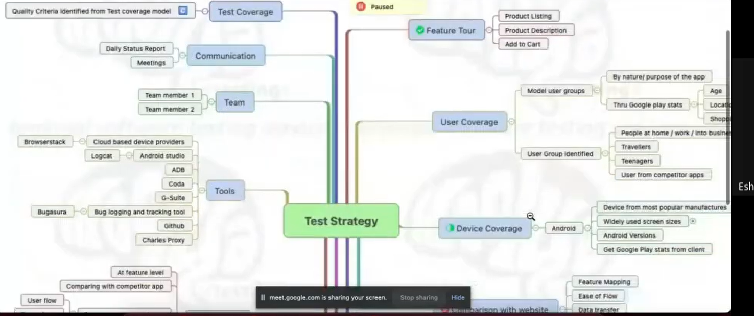

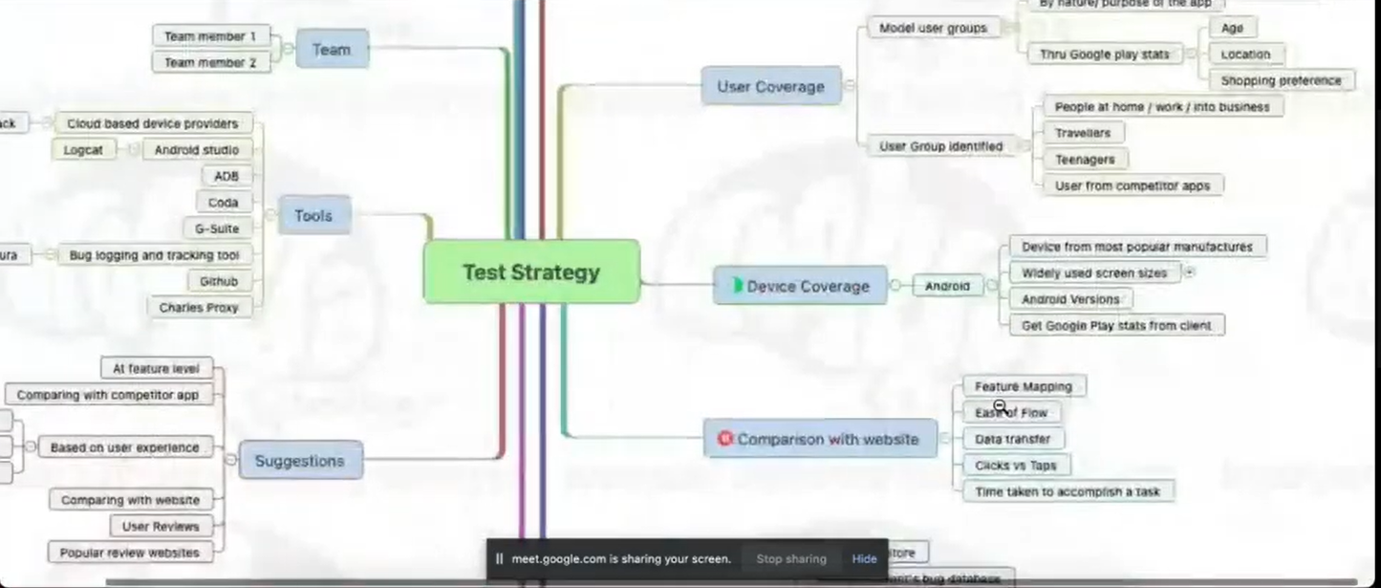

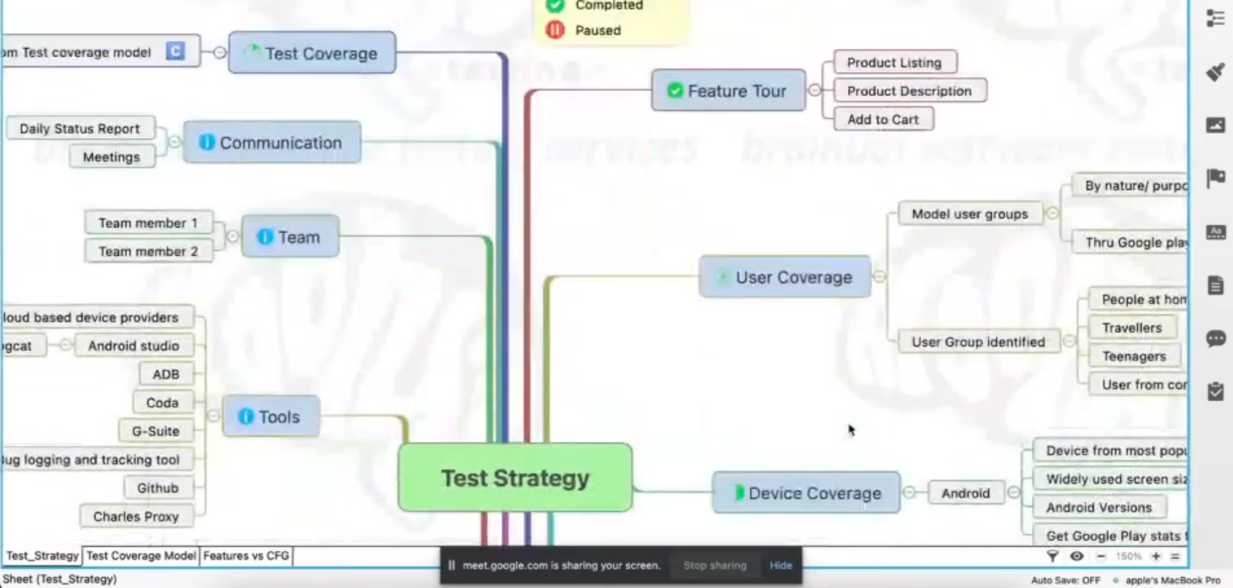

Starts from Here:

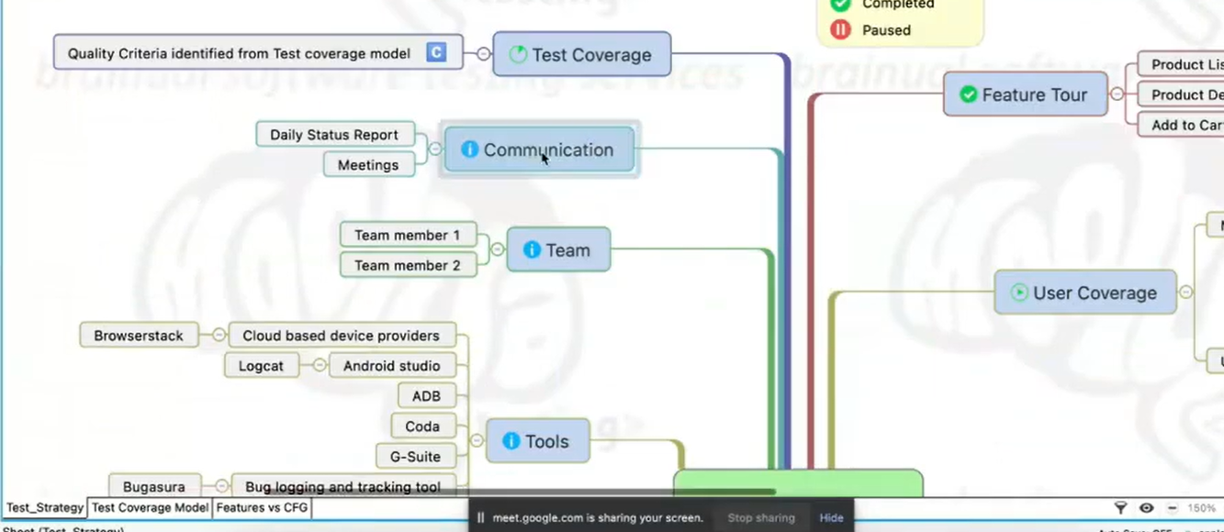

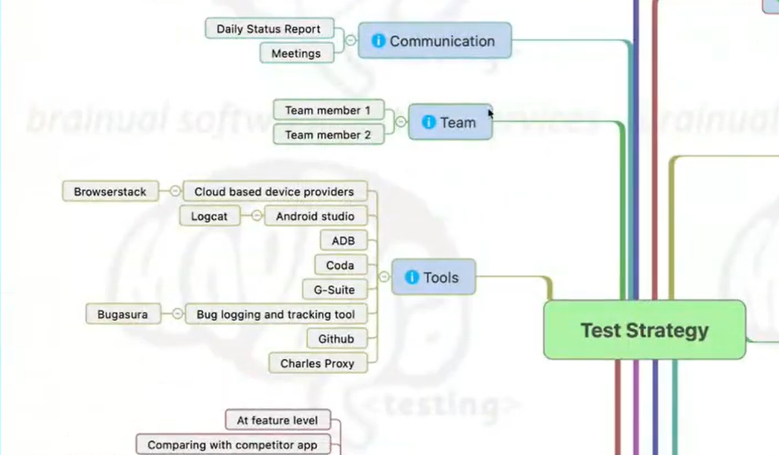

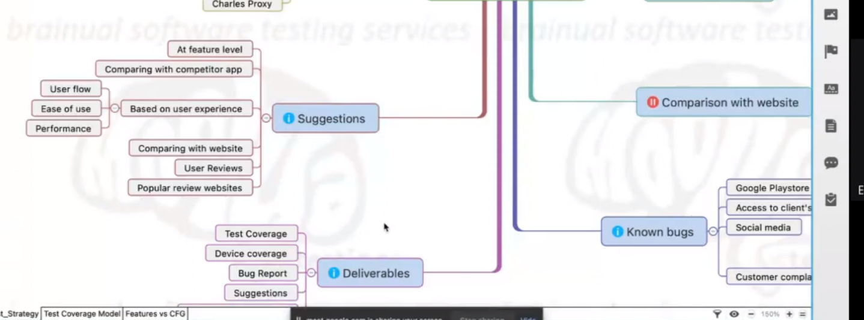

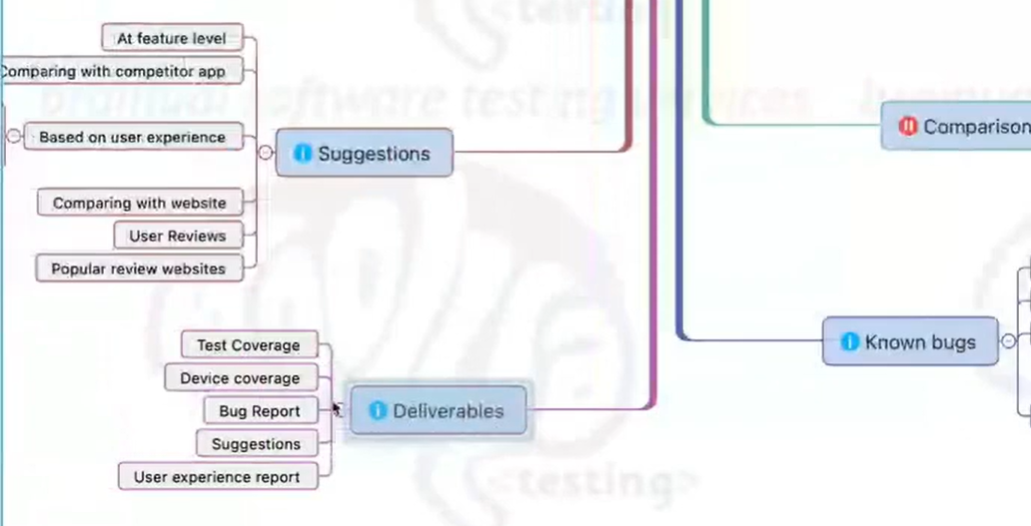

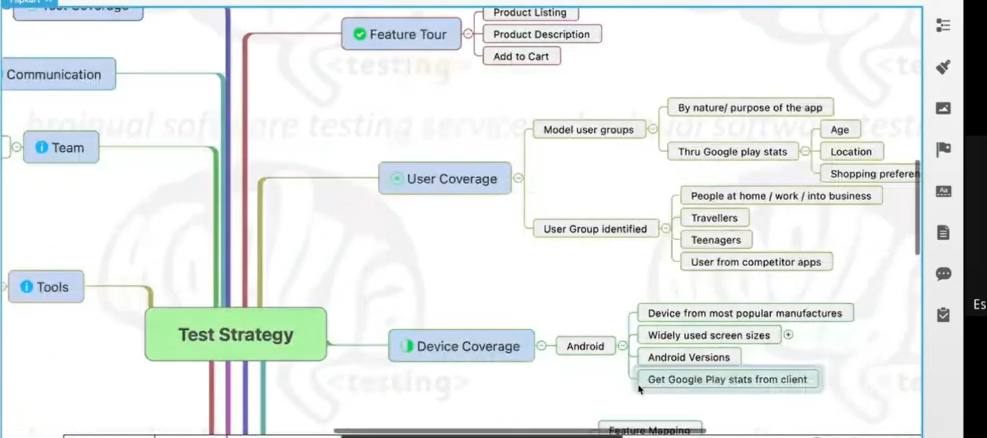

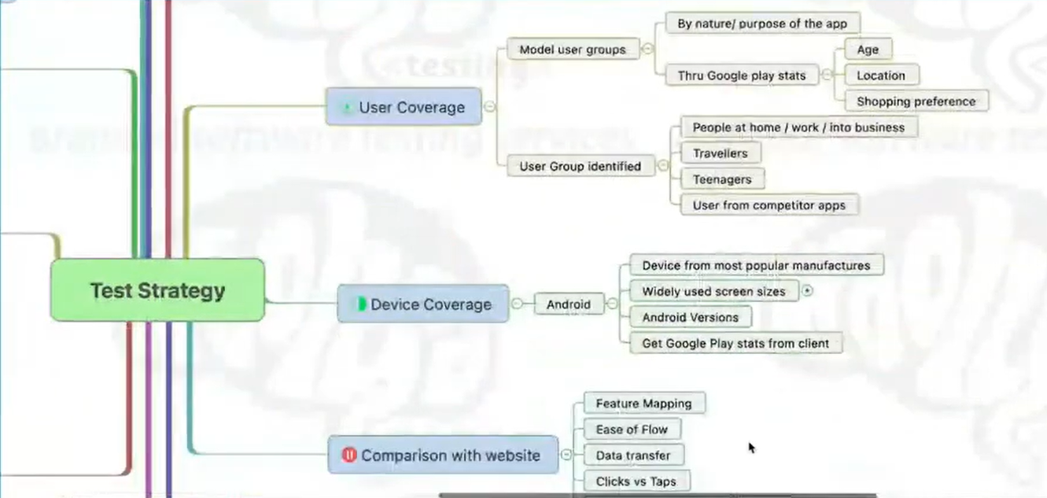

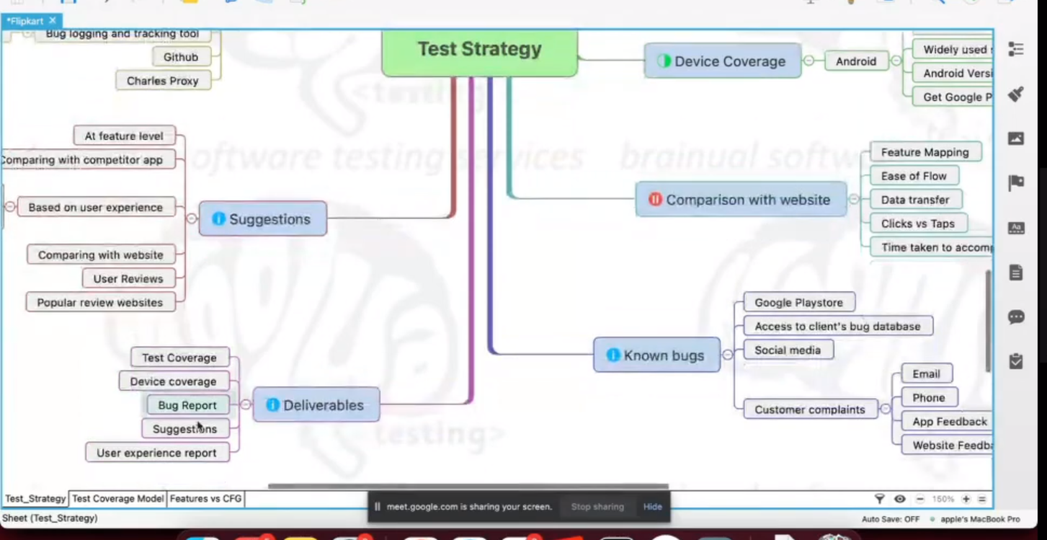

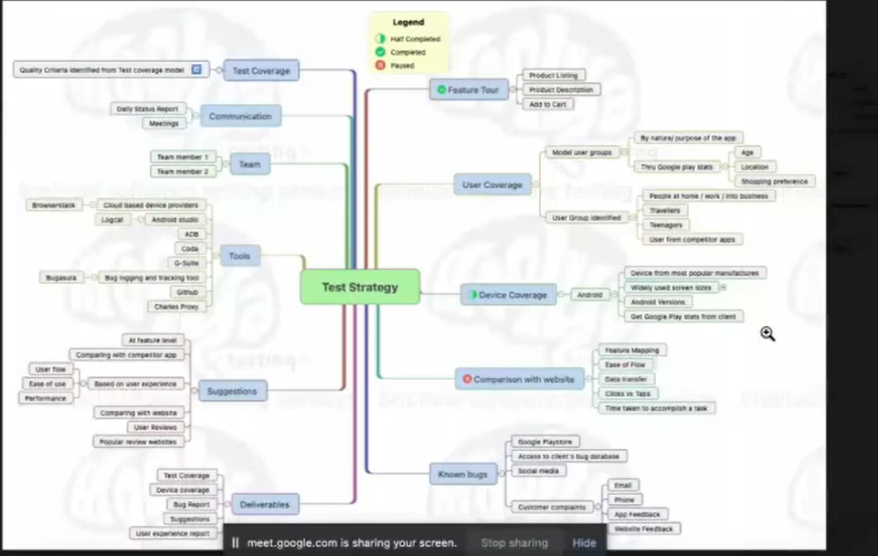

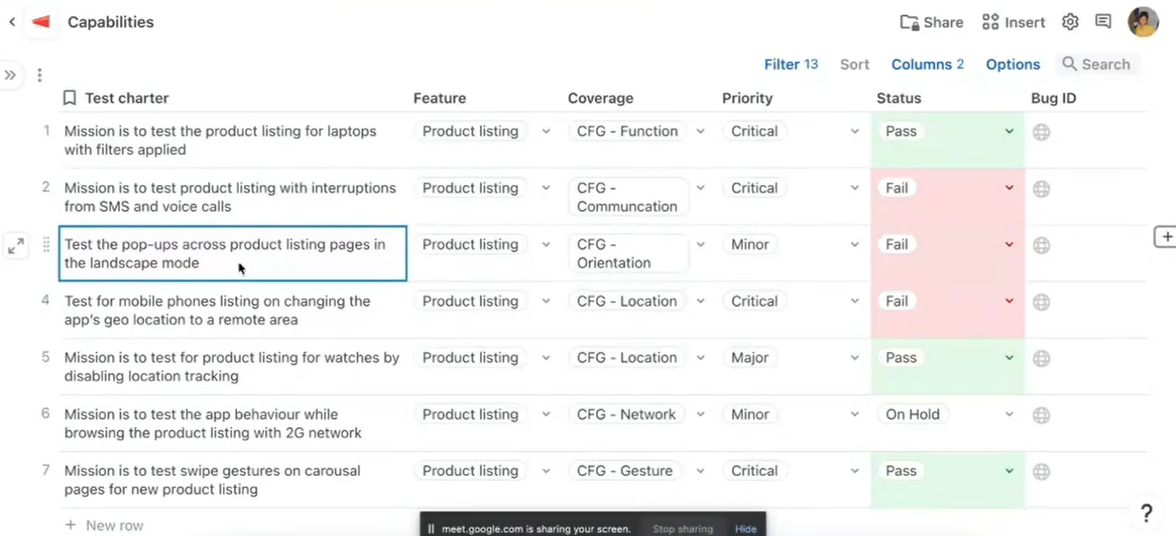

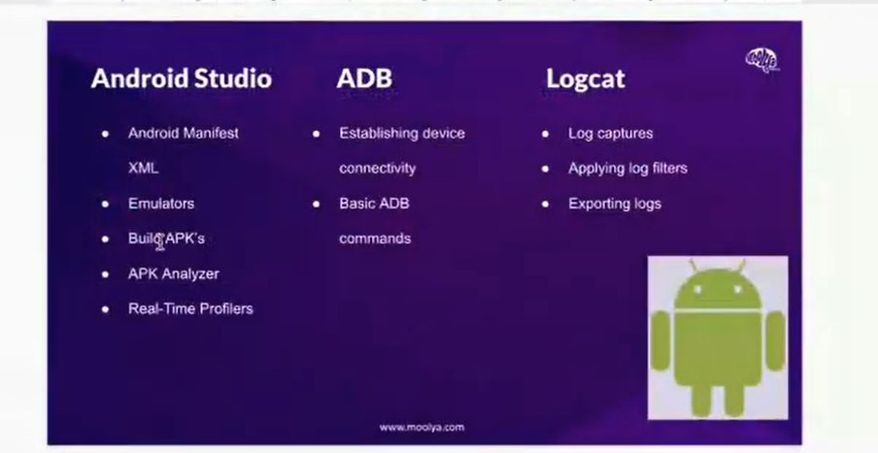

After accesssing the code from github or any source:

